BRANCHLESS BANKING

**INTRODUCTION / DEFINITION:**

In this age of smart-phones and computers - more and more people do all their banking on-line and never go into an actual branch.

Branchless Banking means the provision of banking services or financial services without relying on physical branches.

**WHAT IS BRANCHLESS BANKING?**

Branchless banking is exactly as it sounds – banking without going to a bank. Most of the rural areas are inaccessible. Opening a branch in each village is neither feasible nor profitable. Moreover, the education or literacy level among the population of rural areas is also not very promising. Herein comes to the role of branch less banking.

Branch less banking is the method of delivering banking services outside conventional bank branches. This is mainly done through agents and using communication technology. Mobile phones or point of sale (POS) terminals are the main vehicles through which branchless banking services are delivered in unbanked rural areas.

## Evolution of branchless banking

## This can include the use of smart cards combined with a point-of-sale or point-of-transaction device, mobile money agents, banking correspondents, and many other innovations that bring banking services closer to the consumer at a low cost.

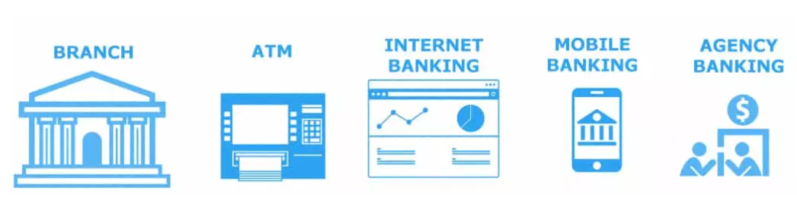

<https://habiletechnologies.com/blog/branchless-banking/#fin_form_pop>

**Branchless Banking vs. Banking at a Branch:**

Banking is supposed to be built around you and your finances, regardless if you use online banking or go to your local branch.

*The real question is, which is better for you and why?*

Both online banks and traditional branches have their advantages – they’re convenient in their own way, provide unique services and offer interest rates as competitive as possible. Which do you prefer? That’s for you to decide, and when you do, Discover Bank is here to answer any questions you have about online banking.

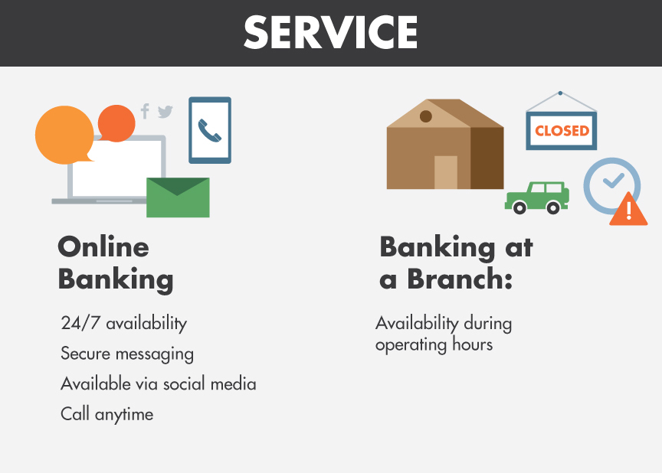

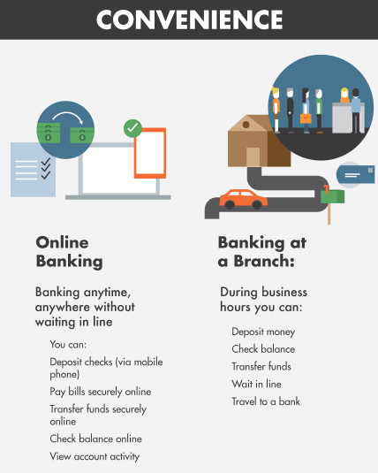

***Reference URL:*** <https://www.discover.com/online-banking/banking-topics/online-vs-branches/>

**The Difference between Mobile banking, Digital Banking and Virtual Banking:**

**Mobile Banking** banks offer a banking app that you can download to your phone.

**Digital Banking** The earliest form of internet banking was logging into your bank account through a bank’s website to complete transactions

**Virtual Banking** There are no branches and there is no paperwork to sign. To open a bank account, you will need to download the mobile banking app. By submitting your details and completing the security checks, you are assigned your virtual account. Your card, linked to your virtual account is delivered to your door, and you’re ready to start virtual banking.

***Reference URL:*** [*https://medium.com/@community_13800/the-difference-between-mobile-banking-digital-banking-and-virtual-banking-2daa250b1f96*](https://medium.com/@community_13800/the-difference-between-mobile-banking-digital-banking-and-virtual-banking-2daa250b1f96)

**Branchless Banking Disadvantages**

Branchless banking via personal computers and mobile apps on cellphones has made banking more convenient and accessible 24 hours a day. However, there are some downsides to online banking. While these disadvantages may not keep you from using online services, keep these concerns in mind to avoid potential issues down the road.

**Technology and Service Interruptions**

Anytime we use computers or internet service, we are at the mercy of the system's stability and efficiency. Your ability to access accounts online will naturally be affected if your internet service is running slowly or completely out for a period of time. Similarly, if the bank's servers go down or are temporarily unavailable

due to scheduled site maintenance, you won't be able to gain online or mobile access to your banking information.

**Security and Identity Theft Concerns**

In general, online banking sites and mobile apps are designed to be secure and banks are continually putting updated security protocols in place. However, no system is completely foolproof and accounts can be hacked, resulting in identity theft via stolen login credentials. So while you can use mobile or online banking with general confidence, be careful to avoid using networks that are not secure and be careful to change passwords and protect your login information.

**Convenient but Not Always Faster**

While it may take very little time to deposit a check via a bank's mobile app, you still need to wait for access to your money. Online banking provides convenience in terms of the amount of time saved in travel or waiting in line at a branch location, but all deposits are reviewed and funds are released for access according to bank policy, which may take up to three business days depending on the amount deposited.

**Lack of Personal Banker Relationship**

For the most part you may be able to handle your general banking needs by yourself. Yet when problems arise if you don't have a personal relationship with a banker, it might be more difficult to get your issues resolved. While online banking sites have customer service departments, you often need to work your way through a phone tree and wait on hold before speaking with someone who has no knowledge of your needs or banking history. In contrast, a local banker is motivated to serve their customers and strengthen their personal relationships.

**RISK IN BRANCHLESS BANKING:**

Thus, it is extremely dangerous to transform the banking system to 100% branchless. Banks will face a great challenge of authentication security and cybercrime. Perhaps there is a way to the second life for the existing network of bank branches.

***Reference URL:*** [https://paymentsnext.com/the-biggest-danger-to-branchless-banking/#:~:text=If%20a%20criminal%20takes%20the,banking%20system%20to%20100%25%20branchless.](https://paymentsnext.com/the-biggest-danger-to-branchless-banking/%23:~:text=If%20a%20criminal%20takes%20the,banking%20system%20to%20100%25%20branchless.)

**Isn’t the virtual branch just online banking?**

Of course, the bank had a range of online banking services. You could check your balance, transfer money, all the usual stuff. However, processes like opening a new account requires human interaction. In our case, the regulators were extremely concerned that if there was no face-to-face contact there were huge security risk and compliance (i.e., AML) issues. It took us some time to convince them that it was not only possible but preferable to have face-to-face contact in the digital world.

That’s the key difference between online banking services and the virtual bank branch. The virtual branch enables your bank employees to provide banking services via your customer’s chosen digital channel. Human contact isn’t removed, it’s encouraged. There are many reasons for this. We know that people–of whatever age–have an emotional attachment to personal contact. When they have a big financial decision to make, they want to speak to someone. It’s clearly easier to up-sell and cross-sell when you’re talking to someone. It helps build security through another layer of authentication.

|  |  |  |
| --- | --- | --- |
| **Basis of Difference** | **Traditional Banking** | **Branchless Banking** |
| **Presence** | Banks exist physically for serving the customers, | Internet banks do not have physical presence as services are provided online. |
| **Time** | It consumes a lot of time as customers have to visit banks to carry out bank transactions like — checking bank balances, transferring money from one account to another. | It does not consume time as customers do not have to visit banks to check bank balances or to transfer money from one account to another. Customers can access their account readily from anywhere with a computer and internet access. |
| **Accessibility** | People have to visit banks only during the working hours. | Internet banking is available at any time and it provides 24 hours access. |
| **Security** | Traditional banking does not encounter e-security threats. | Online banking is the tempting target for hackers. Security is one of the problems faced by customers in accessing accounts through internet. |
| **Finance Control** | Customers who often travel abroad cannot pay close attention and control of their finances. | Customers who often travel abroad can have greater control over their finances. |
| **Expensive** | Customers have to spend money for visiting banks. | Customers do not have to spend money for visiting banks. They can avoid bank charges that may be charged for certain teller transactions or when they pay bills electronically — directly from their account to the merchant. It helps to save money on postal charges. |
| **Cost** | The cost incurred by traditional banks includes a lot of operating and fixed costs. | Such costs are eliminated as the banks do not have physical presence. |
| **Customer Service** | ln traditional banks, the employees and clerical staff of the bank can attend only few customers at a time. | In online banking, the customers do not have to stand in queues to carry out certain bank transactions. |
| **Contact** | Customers can have face to face contact in traditional banking. | Customers can have only electronic contacts. |

***Reference URL:*** <https://accountlearning.com/top-10-differences-between-internet-banking-and-traditional-banking/>

**WHY BRANCHLESS BANKING?**

Mobile phones in hand, customers across the globe are changing how they bank. They are spending much more time online, exploring and using digital channels more for their financial needs. They are banking without going to a bank.

**KEY FEATURES:**

* Digital Onboarding
* Mobile Banking
* Internet Banking
* Contact Center Banking
* Digital Lending
* Digital Collections

**Encouraging mobile payments:**

Unified Payment Interface (UPI) enabled all smartphone users to send and receive money right from their mobile device using the UPI App. Using UPI we could transact without logging in to our bank account or even without the account information of the receiver. In fact, to complete a transaction all a person has to do is enter the recipient’s unique Virtual Payment Address (VPA).

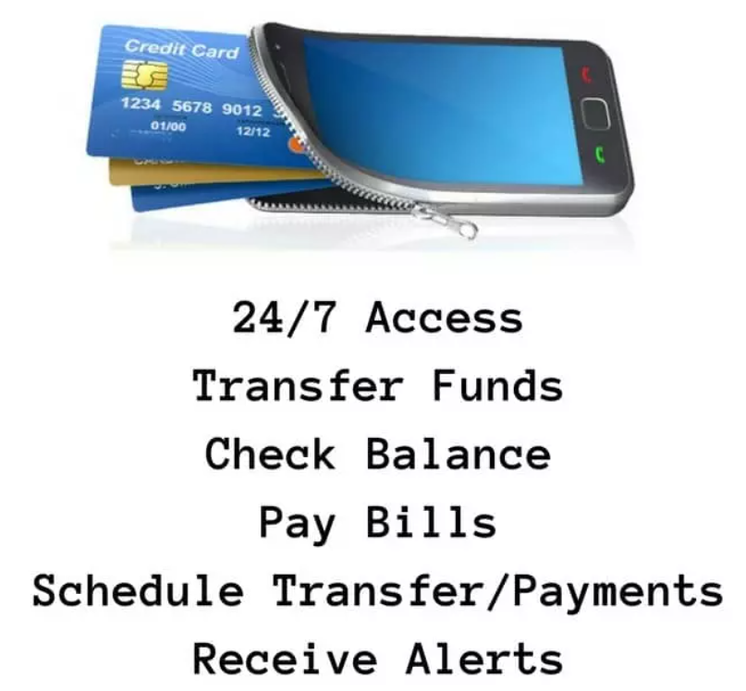

**The rise of branchless banking**

One of the most exciting developments over the last few years has been the rise of branchless banking or direct banking. Branchless banks essentially offer banking services without the traditional network of bank branches. Instead, they serve their customers online or via an independent agent network that allows them to connect with their customer directly.

Digitisation through branchless banking provides opportunities to these players to improve service, reduce costs, build loyalty and commitment in an increasingly fickle banking customer base—critical elements for survival for banks in the Covid-19 and post-Covid world. It also enables banks to meet growing regulatory and market expectations on how they can adequately serve the needs of an ever-expanding digital community.

<https://www.forbesindia.com/blog/finance/banking-2021-without-branches-or-borders/>

#### Branchless Banking: The Emerging Holy Grail

Now it is indisputable that the pandemic will have a far greater impact globally than the 2008 crisis and economies will take longer to turn around

The COVID-19 crisis presents unforeseen challenges to global economies in the immediate, short, and long-term.

Branchless banking is the new mantra of the banking industry. It is the way of offering banking services in unbanked rural areas outside of the traditional bank branches. Business correspondents (BCs) have been effectively bridging the gap between the banking institutions and the unbanked masses located in the rural areas.

***Reference URL:*** <https://bfsi.economictimes.indiatimes.com/blog/branchless-banking-the-emerging-holy-grail/4718>

**Suggestions:**

Based on the above findings, the following recommendations are concluded-

* Awareness level about branchless banking is low. In real what comes in branchless banking people are not aware of it. There is a need for awareness program and authorities have to show concern to promote branchless banking.
* The information on cost and benefit in branch and branch less banking should be passed to users and some percentage of benefit should be given to users who are availing branchless banking.
* Business correspondence must be able to offer their customers a positive and consistent service. They need continual support from the bank to help customer, maintain cash flow and provide technological support for any devices or equipment they utilise.
* The Bank needs to audit the security measures being taken by the agent to ensure the customer can transact confidently.

**Conclusions:**

Being a part of the financial inclusion, Branchless banking model has been termed as an effective tool to provide basic banking services to the under privileged economy and also can be said at a cost and time effectiveness model which saves a lot of expenditure and time both to the customers and the bank.

Branchless banking which presently have no impact on the banking habit of the people due to reasons such as lack of awareness about these facilities, lack of access to the basic delivery channels and infrastructure facilities. Finally, the study concludes that if all the necessary infrastructures and awareness programmes can be put into place, Branchless Banking will be an effective tool for reaching the unbanked people.

Consumers without access to basic [banking](https://bfsi.economictimes.indiatimes.com/tag/banking) facilities have been the most affected due to pandemic situations. “Working hours (business hours) of the banks could be restricted. Door step banking activities should be encouraged”. Not only during this current situations but Branchless banking is always helps the people as per the analysis we made above.